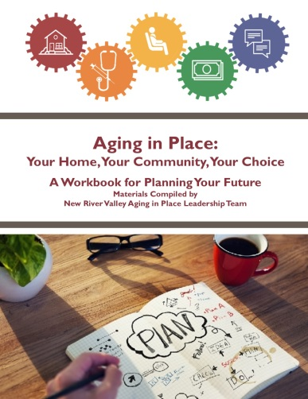
Aging in Place: Your Home, Your Community, Your Choice
Free Planning Workshop

“I’ve lived here for 40 years. No other place will seem like home.”
“The stairs are getting more difficult to climb.”
“I’m having a hard time keeping up with yard and home maintenance.”
“Will my savings run out?”

No one truly knows how their needs might change in their later years, which can make planning for aging in place daunting. It’s also easy to put off for another day, but the sooner you can get proactive about planning for aging in place, the more likely you will be to remain independent and in the home of your choosing. If this interests you, please plan to attend this free workshop on:

Month/Day/Year
Location/Address
start time to end time

The materials for the workshop were developed by the New River Valley, Virginia Aging In Place Leadership Team and will cover five topics: Housing, Health & Wellness, Transportation, Personal Finance, and Connection & Growth.
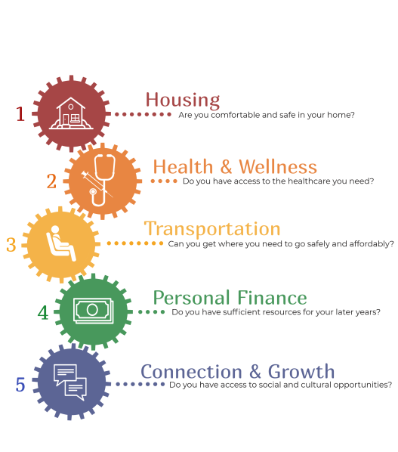

For more information or to register, contact
Name of Workshop Host at
phone number or email.

There is no charge for the workshop or workshop materials, but please register by DATE.
-or-
There is a $$$ fee to cover the cost of workshop materials; please register by DATE.

